Observing System Experiment data challenge– 2021A_SSH_MAPPING_OSE User manual

DOI: XXXXXXXXXXXX

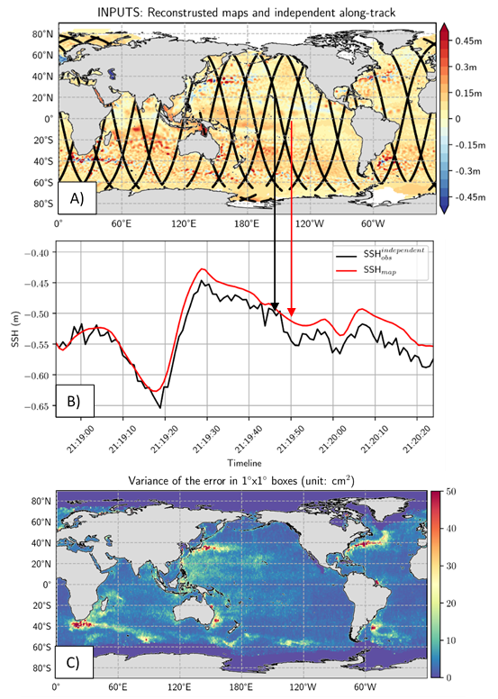

SALP-MU-P-EA- 23469-CLS
Issue 1 rev 0 – 12/01/2021
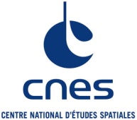

Contents

1 Introduction 3
2 Products description 4
3 Parameters description 5
4 Accessibility of products 6
5 List of acronyms and abbreviations 6
6 References 7

Introduction
The 2021A_SSH_MAPPING_OSE products are altimetry-based sea surface height products. They are designed to carry out Observing System Experiment for assessing, for example, the performance of mapping algorithms with present-day nadir-altimeters constellation. The present document describes each sub-products and variables referenced in 2021A_SSH_MAPPING_OSE.
These products have been computed in collaboration between CLS and the MEOM Team from IGE within the BOOST-SWOT project (https://meom-group.github.io/projects/boost-swot/ ) funded by ANR and the MIDAS project funded by CNES for the NASA/CNES SWOT Science Team. The dissemination of those products is part of the CNES Aviso+ project.

Data Policy and conditions of use
The 2021A_SSH_MAPPING_OSE products are available free of charge for any project or study.

Citation
Publications should include the following statement in the Acknowledgments: “The data used in this study (doi XXXXXXXXXXXXXXXXXX) were developed, validated by CLS and MEOM Team from IGE (CNRS-UGA-IRD-G-INP), France and distributed by Aviso+”.

Products description

2021A_SSH_MAPPING_OSE contains sea-surface-height (SSH) data on 1) several along-track altimeter orbits (SARAL/Altika, Jason 2, Jason 3, Sentinel 3A, Haiyang-2A and Cryosat-2) and 2) several gridded products based on the combinations of the SARAL/Altika, Jason 2, Jason 3, Sentinel 3A, and Haiyang-2A mission (Cryosat-2 being excluded from the mapping).

The processing for the along-track observation production follows the same methodology as the along-track products distributed by the SL-TAC in the Copernicus Marine Service (CMEMS) and described in Pujol et al. (2016) and Taburet et al. (2019).

The gridded datasets contain: the mean dynamic topography CNES-CLS13 (Mulet et al., 2013) and spatio-temporal reconstructions of the SSH based on several mapping techniques such as a “BASELINE” optimal interpolation (as described in the github data-challenge repository https://github.com/ocean-data-challenges/2021a_SSH_mapping_OSE), a DUACS-DT2018 optimal interpolation (Taburet et al., 2019), a dynamic (DYMOST) interpolation method (Ubelmann et al, 2015, 2016; Ballarotta et al. 2020), a multiscale (MIOST) mapping approach (Ubelmann et al., 2021a, 2021b) and a method based on Back-and-Forth Nudging (BFN) a One-Layer Quasigeostrophic Model (Le Guillou et al. 2021)

The present datasets focus on a 10°x10° area in the GulfStream system.

Products | Mission | Period Coverage | Spatial Coverage
Along-Track | SARAL/Altika | 2016/12/01-2018/01/31 | 75°W-45°W  23°N-53°N
 | Jason-2 | 2016/12/01-2017/09/14
 | Jason-3 | 2016/12/01-2018/01/31
 | Sentinel-3A | 2016/12/01-2018/01/31
 | Haiyang-2A | 2016/12/01-2018/01/31
 | Cryosat-2 | 2016/12/01-2018/01/31
Mean dynamic Topography (CNES-CLS13) | grid | - | 65°W-55°W  33°N-43°N
DUACS mapping gridded SSH | grid | 2017/01/01-2017/12/31
DYMOST mapping gridded SSH | grid | 2017/01/01-2017/12/31
MIOST mapping gridded SSH | grid | 2017/01/01-2017/12/31
BFN mapping gridded SSH | grid | 2017/01/01-2017/12/31
BASELINE mapping gridded SSH | grid | 2017/01/01-2017/12/31
Table 1. Products’ characteristics

Parameters description
List of the parameters available in each product.
NetCDF name | Units | Short description
latitude | degrees_north | Latitude coordinates of the measurement
longitude | degrees_east | Longitude coordinates of the measurement
cycle | - | Cycle the measurement belongs to
track | - | Track in cycle the measurement belongs to
dac | meters | Dynamic Atmospheric Correction
lwe | meters | Long wavelength error
mdt | meters | Mean dynamic topography
ocean_tide | meters | Ocean tide model
sla_filtered | meters | Sea level anomaly filtered not-subsampled with dac, ocean_tide and lwe correction applied
sla_unfiltered | meters | Sea level anomaly not-filtered not-subsampled with dac, ocean_tide and lwe correction applied
time | seconds since 2016-12-01 | Time coordinates of the measurement
Table 2. Short description of all parameters available in Netcdf Along track files.

NetCDF name | Units | Short description
lat | degrees_north | Latitude coordinates of the reconstruction
lon | degrees_east | Longitude coordinates of the reconstruction
ssh | meters | Reconstrcution SSH
time | days since 2017-01-01 00:00:00 | Date of the reconstruction
Table 3: List of variables in the NetCDF grid products.

Accessibility of products
The products are available via the authenticated Aviso+ OpenDAP:
- You first need to register via the Aviso+ web portal and sign the License Agreement: https://www.aviso.altimetry.fr/en/data/data-access/registration-form.html
- Please, choose the product “Ocean data challenge” in the list of products
A login /Password will be provided via email with all the necessary information to access the products.

List of acronyms and abbreviations
FTP: File Transfer Protocol
OSE: Observing System Experiment
SLA: Sea Level Anomaly
SSH: Sea Surface Height
BFN: Back-and-Forth Nudging
DUACS: Data Unification and Altimeter Combination System
CMEMS: Copernicus Marine and Environment Monitoring Service

References

Ballarotta, M., and et al. , 2020: Dynamic mapping of along-track ocean altimetry: Performance from real observations. J. Atmos. Oceanic Technol., 37, 1593–1601, https://doi.org/10.1175/JTECH-D-20-0030.1.

Le Guillou, F, and et al. , 2021: Mapping Altimetry in the Forthcoming SWOT Era by Back-and-Forth Nudging a One-Layer Quasigeostrophic Model, J. Atmos. Oceanic Technol., 38, 697-710, https://doi.org/10.1175/JTECH-D-20-0104.1

Mulet, S., Rio, M. H., Greiner, E., Picot, N., and Pascual, A.: New global Mean Dynamic Topography from a GOCE geoid model, altimeter measurements and oceanographic in-situ data, OSTST Boulder USA 2013, available at: http://www.aviso.altimetry.fr/fileadmin/documents/OSTST/2013/oral/mulet_MDT_CNES_CLS13.pdf (last access: 31 August 2016), 2013.

Taburet, G., Sanchez-Roman, A., Ballarotta, M., Pujol, M.-I., Legeais, J.-F., Fournier, F., Faugere, Y., and Dibarboure, G.: DUACS DT-2018: 25 years of reprocessed sea level altimeter products, Ocean Sci. , https://www.ocean-sci.net/15/1207/2019/,2019

Pujol, M.-I., Faugère, Y., Taburet, G., Dupuy, S., Pelloquin, C., Ablain, M., and Picot, N.: DUACS DT2014: the new multi-mission altimeter data set reprocessed over 20 years, Ocean Sci., 12, 1067-1090, doi:10.5194/os-12-1067-2016, 2016.

Ubelmann, C., P. Klein, and L. Fu, 2015: Dynamic interpolation of sea surface height and potential applications for future high-resolution altimetry mapping. J. Atmos. Oceanic Technol., 32, 177–184, https://doi.org/10.1175/JTECH-D-14-00152.1.

Ubelmann, C., B. Cornuelle, and L. Fu, 2016: Dynamic mapping of along-track ocean altimetry: Method and performance from observing system simulation experiments. J. Atmos. Oceanic Technol., 33, 1691–1699, https://doi.org/10.1175/JTECH-D-15-0163.1.

Ubelmann, C., Dibarboure, G., Gaultier, L., Ponte, A., Ardhuin, F., Ballarotta, M., and Faugère, Y.: Reconstructing Ocean Surface Current Combining Altimetry and Future Spaceborne Doppler Data, Journal of Geophysical Research: Oceans, 126, e2020JC016 560, https://doi.org/https://doi.org/10.1029/2020JC016560, e2020JC016560 2020JC016560, 2021a

Ubelmann, C., Carrere, L., Durand, C., Dibarboure, G., Faugère, Y., Ballarotta, M., Briol, F., and Lyard, F.: Simultaneous estimation of Ocean mesoscale and coherent internal tide Sea Surface Height signatures from the global Altimetry record, Ocean Sci. Discuss. [preprint], https://doi.org/10.5194/os-2021-80, in review, 2021b.

